Gardening As My Favorite Hobby
Institution Affiliation
Student’s Name
Date

Gardening As My Favorite Hobby
Introduction
Through the course of my life, I usually commit myself to most of the duties that can help me to earn a living and to build a foundation for my future career. Besides these compulsory work, I do other activities that I enjoy doing them in my life because they help me to avoid the daily grind of life and task and it gives me the pleasure and peace of mind (Robbins & Seibel, 2019). My favorite hobby is gardening; I found it as my happiness to see the blooming flowers and green leaves that create a sense of achievement in my heart and to realize that the work of my hands bears fruits and eventually giving me pleasure. I gained that passion for gardening from my mother, who is very supportive and encouraging. According to McFarland et al. (2018), gardening as an activity that subjects people to gratitude for work rather than pushing them away from it.
The most exciting thing with my hobby is that it helps me to improve on my personality, traits, therefore, enabling me to develop better performance throughout my lifetime. It has also helped me to realize my potential and ability to work that I may not have known. Generally, gardening as my hobby gives me an understanding of the environment, making me get new ideas each day about the surrounding. According to Gross, (2018), gardening helps me to maintain my body fitness, it keeps me secure and healthy, and so working in my garden brings about some real significances of my body and mind. In my garden, I grow different types of plants such as ferns, gladioli, jasmine, and China rose plant. It is usually my responsibility to look after my plants in my garden after school to ensure that they grow without any interference.
Conclusion
Even though many people perceive gardening as an agricultural activity that is labor-intensive, I usually take it to be simple and enjoying the action. This is because of the advantages I gain by involving myself in these activities like, the pleasure and peace of mind because my garden is located at a cool place that is entirely free from disturbances. It also helps me to improve on my own personality and to be aware about the living and non-living things surrounding us. I usually develop a great feeling to see my orchard well-regarded and valued by people that makes me feel like I have achieved a great goal in my life.
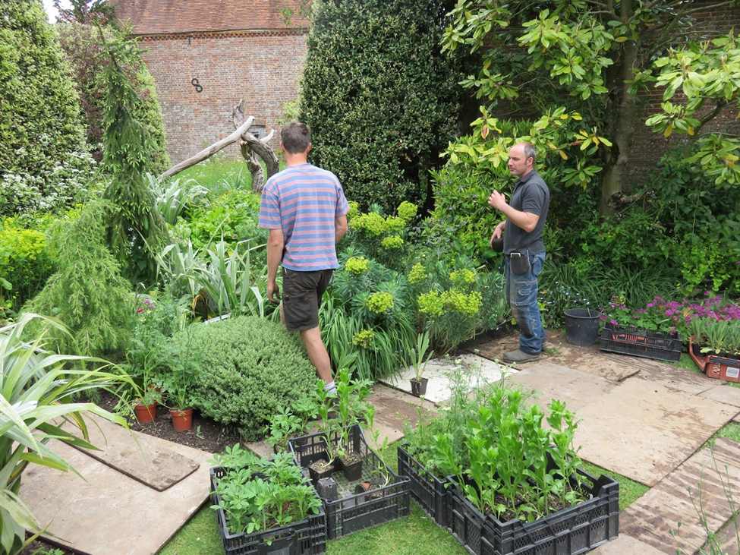https://1.bp.blogspot.com/-XHzidv8rfxU/V0w8H-T2F9I/AAAAAAAAJGw/VcVxTv-R97Eulw7vk55PN28mYFk5B3xVwCLcB/s1600/IMG_3312.JPG

References
Gross, H. (2018). The Psychology of Gardening. Routledge.
McFarland, A., Waliczek, T. M., Etheredge, C., & Lillard, A. J. S. (2018). Understanding Motivations for Gardening Using a Qualitative General Inductive Approach. HortTechnology, 28(3), 289-295.
Robbins, J. C., & Seibel, K. A. (2019). Temporal aspects of wellbeing in later life: gardening among older African Americans in Detroit. Ageing & Society, 1-21.

